Statement of Readiness Template
Mental Health & Wellness MOU Funding

Use of this template is optional. If you have other documents that provide the information requested you can submit those or you can attach the documents and note in the sections below. You can write as much as you would like in each section as the rows will expand.
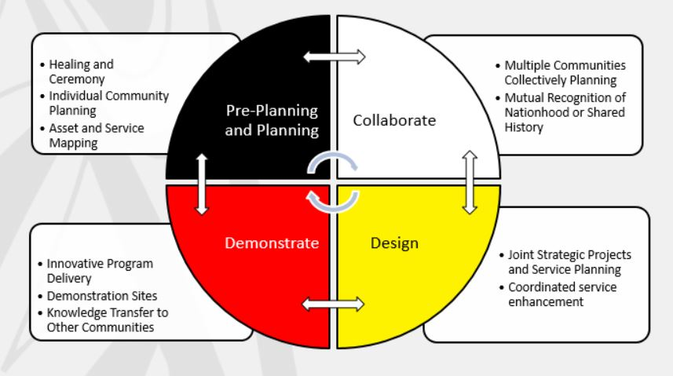
Please check the quadrant that your Statement of Readiness aligns to:
☐ Pre-Planning/Planning
☐ Collaborate
☐ Design
☐ Demonstrate
Date of Statement:
Submission Contact Person:
Submission Contact Community/Nation:
Submission Contact Email/Phone:
Region:
Single Funding Recipient:

Communities/Nations participating
Partners participating or partner assistance needed. (The Mental Health & Wellness Table can assist in making partner connections to support development and implementation.)
What are your wholistic Mental Health & Wellness goals for this quadrant?
What are your planned activities for this quadrant that will help you achieve your vision of mental health and wellness?
What are your timelines for the activities?
How will you measure progress? (Consider what you expect will be created by the end of your activities such as a plan which are called outputs. Consider what changes will occur as a result of your activities which are called outcomes. Include any indicators you will be using to measure success.)
Budget Requirements (Add additional lines as needed or you can attach a budget document)
Item/Activity | Cost
Total Budget:
Additional documents attached:
☐ Implementation Plan (for the Demonstrate quadrant)
☐ Letters of Support (from participating communities/Nations and partners as needed)
☐ Other (Describe) _________________________________
☐ Other (Describe) _________________________________
☐ Other (Describe) _________________________________
NOTE: Band Council Resolutions or Letter of Intent for Tribal Councils or Treaty may be needed for contribution agreements.
*Send completed Statements of Readiness to mhwmou@fnha.ca

