FNHA 2019 Winter Wellness Grants Application Guidelines
The First Nations Health Authority (FNHA) envisions healthy, self-determining and vibrant BC First Nations children, families, and communities playing an active role in decision-making regarding their personal and collective wellness. The Winter Wellness Grants are in line with Directive #1: Community-Driving, Nation-Based, the FNHA is encouraging First Nations to create their own health event or initiative!
Grant eligibility
First Nations communities as well as organizations, schools, and agencies that are engaged in direct services delivery to BC First Nations and/or Indigenous people may be eligible for funding to host a Community-Driven Winter Wellness event or initiative.
To be eligible, the event or initiative must be held between: January 1 – February 16, 2020.
Deadline for applications is October 25, 2019.
If you have received a Day of Wellness or Winter Wellness grant funds in the past, previous closing reports must be submitted before applying for new funds.
Theme
The theme for 2020 is “Be My Guest- Youth for Elders”. The focus is on youth designing events to hold with or for Elders; including inter-generational connections and youth developing skills in event planning and knowledge of traditional protocol. Winter is the time of the year to reflect and use our ceremonies to start the New Year in a good way, to sustain our wellness for the year. Here at the FNHA, we want Wellness events and initiatives to include culture and holistic approaches to health to achieve a balance in our mental, spiritual, emotional and physical wellness.

Application Process
Applications for a Winter Wellness Grant can be completed:
Online: https://interceptum.com/si/en/4700653
Email: Active@fnha.ca for an application form and submit final report
Website: www.fnha.ca
Fax: by phoning 604-456-7621 or 604-693-6906 for a paper/fax application form
*Only fully completed application forms will be considered. When internet connectivity is available, it is preferred that FNHA receives applications online.
Review and Assessment
Applications will be weighed against the following criteria:
- Includes the theme of “Be My Guest- Youth for Elders”.
- Event or initiative focuses on one or more of the FNHA Wellness Streams,
  - See page 3 for a breakdown of the wellness streams & examples.
- BC First Nations community-based applications,
- Collaboration and partnerships with other communities are possible and demonstrated at the regional, or sub-regional level,
- Fairness and equity within and across the five regions.

The Review and Assessment process will take place from October 28 to November 22, 2019.

Four Wellness Streams and First Nations Perspective on Health and Wellness
​To achieve a healthy lifestyle, the First Nations Health Authority has identified 4 key Wellness Streams. These Streams represent wellness areas that - if pursued - could greatly improve First Nations health and wellness. Setting goals in each of these Wellness Streams can have major impacts on your health.
 |  | Example of use
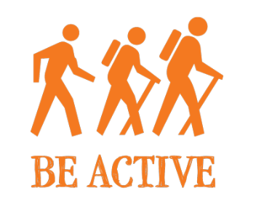 | You know that exercise is healthy for your body, but don’t forget that it’s also a great way to manage stress, anxiety and mood.  Feel like you have no time to exercise? Remember, every minute of activity counts. Consider trying some of these tips:  • Keep a pair of walking shoes at work  • Keep clothes you need for a workout in your car  • Keep hand weights near your television or phone  When an opportunity for exercise comes along you’ll be ready. | In 2019, the Tl’etiqox Government hosted Tsilqot’in Winter Carnival & Skidoo Race. There was skidoo races and other fun events such as sliding, egg racing, snowshoe race, cross-country skiing, dice throws and polar dip.
 | Nutrition is the foundation in maintaining good health. There are many, many resources available on healthy eating. It is about taking the time and finding the resources that resonate with your specific needs, (i.e. sodium-free, gluten-free, vegetarian diets, etc). | In 2018, the Yaqqan Nukiy (Lower Kootenay Ban) hosted traditional food preparation activities, including a “Master Chef” contest.
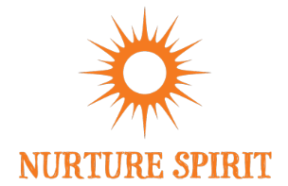 | ​Nurturing spirit is the aspect in your life that makes you smile! This is about what makes you feel good and connected. This builds your self-esteem, self-confidence and allows you to be connected to others, mother nature and yourself. Nurturing your spirit supports your mental, emotional and physical aspects of your being.  Even though your spirit is fundamental in your wellness it is often overlooked or not supported when discussing your health. | In 2019, the Nisga’a Village of Gingolx hosted Hobiyee 2019. A two-day cultural celebration of the crescent moon when the Nisga’a’ People watch for the positioning of the moon and the stars as a prediction of the coming harvest. Sharing stories, songs, and dances throughout the two days.
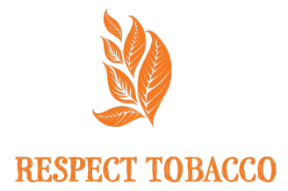 | For thousands of years, natural tobacco has been an integral part of Aboriginal culture in many parts of British Columbia and Canada. Used in ritual, ceremony, and prayer, tobacco was considered a sacred plant with immense healing and spiritual benefits. For these reasons, the tobacco plant should be treated with great respect.  We should also be very careful not to confuse traditional tobacco and its sacred uses with commercial tobacco and the addiction epidemic we see today. | In 2018, School District 19 hosted a Smoke-Free initiative for 48 hours. The challenge included a walk that concluded in recognizing those who have completed the 48 hour challenge. Resources were also provided to participants and those interested.

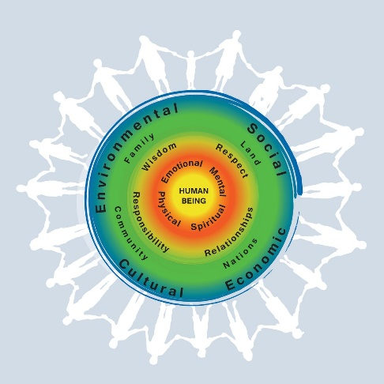
The First Nations Perspective on Health and Wellness aims to visually depict and describe the First Nations Health Authority Vision: Healthy, Self-Determining and Vibrant BC First Nations Children, Families and Communities.

This visual depiction of the Perspective on Health and Wellness is a tool for the​​​ FNHA and First Nations Communities. It aims to create shared understanding of an holistic vision of wellness. This image is just a snapshot of a fluid concept of wellness: it can be adapted and customized freely and is not confined to remain the same.

